mounting a vmdk on a new VM

for editing. In this case we were trying to change the root(admin) passwd on lacpivap. We mounted on lacfe to do the editing.

Power down lacpivap (to prevent any access problems due to both VMs trying to access the file.

vSphere => select VM => RT click select edit settings

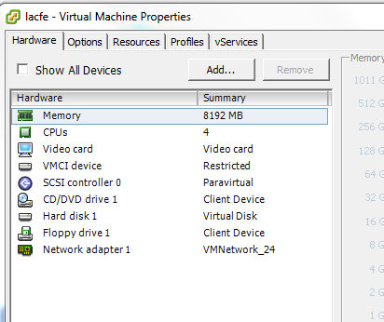

click Add

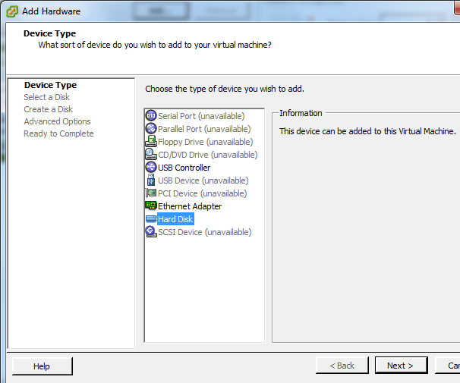

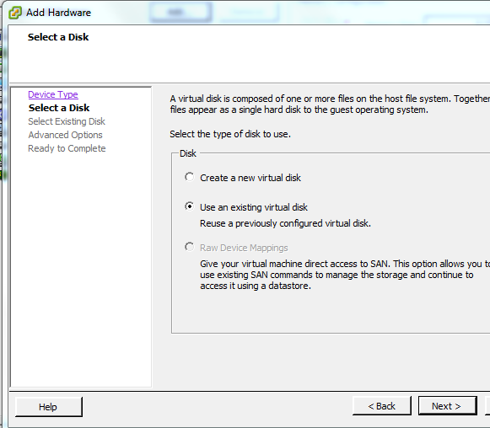

click Browse

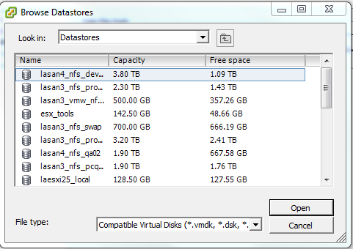

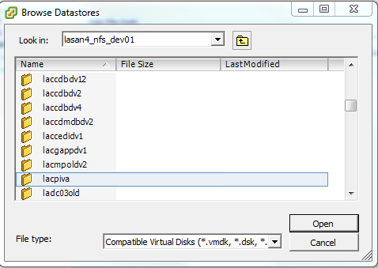

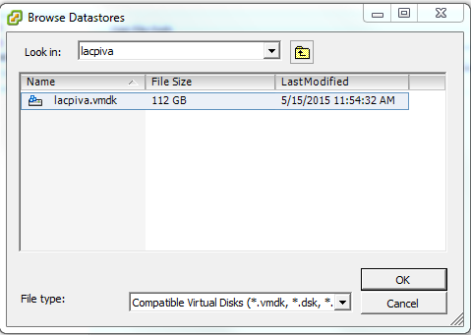

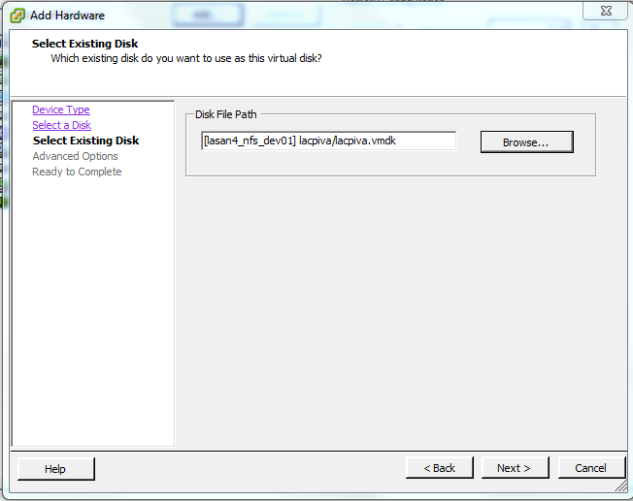

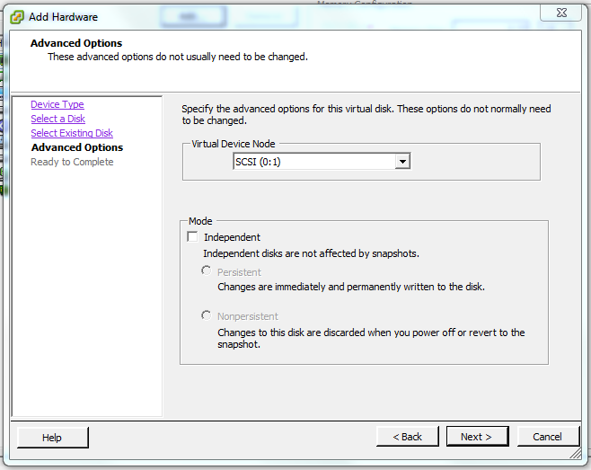

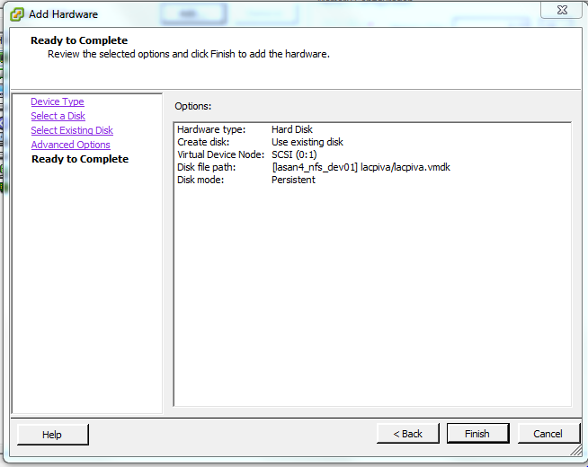

At this point the vmdk is available on lacfe….

dsiegfri@la1002073d:~ $ ssh lacfe

dsiegfri@lacfe's password:

Last login: Fri Apr 3 09:48:06 2015 from 10.130.8.176

[dsiegfri@lacfe ~]$

[dsiegfri@lacfe ~]$ su -

Password:

[root@lacfe ~]#

[root@lacfe ~]# vgscan

Reading all physical volumes. This may take a while...

Found volume group "vg_lacfe" using metadata type lvm2

[root@lacfe ~]#

[root@lacfe ~]# vgscan

Reading all physical volumes. This may take a while...

Found volume group "smosvg" using metadata type lvm2

Found volume group "vg_lacfe" using metadata type lvm2

[root@lacfe ~]#

[root@lacfe ~]# vgchange -a y

11 logical volume(s) in volume group "smosvg" now active

6 logical volume(s) in volume group "vg_lacfe" now active

[root@lacfe ~]#

[root@lacfe ~]# lvs

LV VG Attr LSize Pool Origin Data% Meta% Move Log Cpy%Sync Convert

altrootvol smosvg -wi-a----- 96.00m

home smosvg -wi-a----- 96.00m

localdiskvol smosvg -wi-a----- 43.94g

optvol smosvg -wi-a----- 206.22g

recvol smosvg -wi-a----- 96.00m

rootvol smosvg -wi-a----- 3.91g

storeddatavol smosvg -wi-a----- 9.75g

swapvol smosvg -wi-a----- 15.62g

tmpvol smosvg -wi-a----- 1.94g

usrvol smosvg -wi-a----- 6.81g

varvol smosvg -wi-a----- 3.91g

LogVol00 vg_lacfe -wi-ao---- 3.91g

LogVol01 vg_lacfe -wi-ao---- 4.88g

LogVol02 vg_lacfe -wi-ao---- 3.91g

LogVol03 vg_lacfe -wi-ao---- 29.30g

LogVol04 vg_lacfe -wi-ao---- 2.93g

LogVol05 vg_lacfe -wi-ao---- 5.86g

[root@lacfe ~]#

[root@lacfe ~]# pvs

PV VG Fmt Attr PSize PFree

/dev/sda2 vg_lacfe lvm2 a-- 69.51g 18.73g

/dev/sdb3 smosvg lvm2 a-- 292.38g 0

[root@lacfe ~]#

[root@lacfe ~]# lvdisplay

--- Logical volume ---

LV Path /dev/smosvg/rootvol

LV Name rootvol

VG Name smosvg

LV UUID 6i3DpX-V1dG-ldsn-MAiK-QaIA-m1eZ-M1HgVy

LV Write Access read/write

LV Creation host, time ,

LV Status available

# open 0

LV Size 3.91 GiB

Current LE 125

Segments 1

Allocation inherit

Read ahead sectors auto

- currently set to 256

Block device 253:6

--- Logical volume ---

LV Path /dev/smosvg/storeddatavol

LV Name storeddatavol

VG Name smosvg

LV UUID 1Jh2B6-NkfF-o2xg-6Pow-XfQR-e3Vr-82ifKI

LV Write Access read/write

LV Creation host, time ,

LV Status available

# open 0

LV Size 9.75 GiB

Current LE 312

Segments 1

Allocation inherit

Read ahead sectors auto

- currently set to 256

Block device 253:7

--- Logical volume ---

LV Path /dev/smosvg/localdiskvol

LV Name localdiskvol

VG Name smosvg

LV UUID Fbk9RP-5Rkr-6ohu-GEHk-xZ6K-SACA-gs7g5l

LV Write Access read/write

LV Creation host, time ,

LV Status available

# open 0

LV Size 43.94 GiB

Current LE 1406

Segments 1

Allocation inherit

Read ahead sectors auto

- currently set to 256

Block device 253:8

--- Logical volume ---

LV Path /dev/smosvg/home

LV Name home

VG Name smosvg

LV UUID Ka7Dl8-Wv4v-H7HK-ov9q-yTpA-1B0J-Ou5AaY

LV Write Access read/write

LV Creation host, time ,

LV Status available

# open 0

LV Size 96.00 MiB

Current LE 3

Segments 1

Allocation inherit

Read ahead sectors auto

- currently set to 256

Block device 253:9

--- Logical volume ---

LV Path /dev/smosvg/optvol

LV Name optvol

VG Name smosvg

LV UUID H2WXHh-VWfq-QueC-9tw6-veUv-T0z0-WBPtqG

LV Write Access read/write

LV Creation host, time ,

LV Status available

# open 0

LV Size 206.22 GiB

Current LE 6599

Segments 1

Allocation inherit

Read ahead sectors auto

- currently set to 256

Block device 253:10

--- Logical volume ---

LV Path /dev/smosvg/varvol

LV Name varvol

VG Name smosvg

LV UUID ER2F32-JMYV-pZLh-vYyf-BfzS-PIuc-JTqr21

LV Write Access read/write

LV Creation host, time ,

LV Status available

# open 0

LV Size 3.91 GiB

Current LE 125

Segments 1

Allocation inherit

Read ahead sectors auto

- currently set to 256

Block device 253:11

--- Logical volume ---

LV Path /dev/smosvg/usrvol

LV Name usrvol

VG Name smosvg

LV UUID 3JY3S1-QBlu-soJw-pNwd-HHZI-jyQg-Soo2b1

LV Write Access read/write

LV Creation host, time ,

LV Status available

# open 0

LV Size 6.81 GiB

Current LE 218

Segments 1

Allocation inherit

Read ahead sectors auto

- currently set to 256

Block device 253:12

--- Logical volume ---

LV Path /dev/smosvg/tmpvol

LV Name tmpvol

VG Name smosvg

LV UUID XHYUcn-zhOb-y9WT-MjSG-RyRl-c9AC-QZ5p1B

LV Write Access read/write

LV Creation host, time ,

LV Status available

# open 0

LV Size 1.94 GiB

Current LE 62

Segments 1

Allocation inherit

Read ahead sectors auto

- currently set to 256

Block device 253:13

--- Logical volume ---

LV Path /dev/smosvg/recvol

LV Name recvol

VG Name smosvg

LV UUID 5fA5Eo-BH10-ctvU-jtiD-J8Mh-FEMg-AVA72B

LV Write Access read/write

LV Creation host, time ,

LV Status available

# open 0

LV Size 96.00 MiB

Current LE 3

Segments 1

Allocation inherit

Read ahead sectors auto

- currently set to 256

Block device 253:14

--- Logical volume ---

LV Path /dev/smosvg/altrootvol

LV Name altrootvol

VG Name smosvg

LV UUID K0YCba-Iq1Q-4OSJ-mf1j-Jf81-WHZe-MgSwR9

LV Write Access read/write

LV Creation host, time ,

LV Status available

# open 0

LV Size 96.00 MiB

Current LE 3

Segments 1

Allocation inherit

Read ahead sectors auto

- currently set to 256

Block device 253:15

--- Logical volume ---

LV Path /dev/smosvg/swapvol

LV Name swapvol

VG Name smosvg

LV UUID Lps8FU-UGWu-dR3s-goc6-c8it-WFpX-kXgAlW

LV Write Access read/write

LV Creation host, time ,

LV Status available

# open 0

LV Size 15.62 GiB

Current LE 500

Segments 1

Allocation inherit

Read ahead sectors auto

- currently set to 256

Block device 253:16

--- Logical volume ---

LV Path /dev/vg_lacfe/LogVol05

LV Name LogVol05

VG Name vg_lacfe

LV UUID DSY8Ky-5RLK-sMmm-Iyn9-WctJ-Crr3-xjqmcg

LV Write Access read/write

LV Creation host, time lacfe.ri-net.com, 2015-03-24 13:00:06 -0700

LV Status available

# open 1

LV Size 5.86 GiB

Current LE 1500

Segments 1

Allocation inherit

Read ahead sectors auto

- currently set to 256

Block device 253:1

--- Logical volume ---

LV Path /dev/vg_lacfe/LogVol04

LV Name LogVol04

VG Name vg_lacfe

LV UUID zPdzA4-wE7z-3oLL-UOvy-a5Gs-eqvm-GfdFUb

LV Write Access read/write

LV Creation host, time lacfe.ri-net.com, 2015-03-24 13:00:08 -0700

LV Status available

# open 1

LV Size 2.93 GiB

Current LE 750

Segments 1

Allocation inherit

Read ahead sectors auto

- currently set to 256

Block device 253:2

--- Logical volume ---

LV Path /dev/vg_lacfe/LogVol01

LV Name LogVol01

VG Name vg_lacfe

LV UUID U3K5p2-lTxJ-4jrQ-gGhc-4192-I8kw-os4kNP

LV Write Access read/write

LV Creation host, time lacfe.ri-net.com, 2015-03-24 13:00:09 -0700

LV Status available

# open 1

LV Size 4.88 GiB

Current LE 1250

Segments 1

Allocation inherit

Read ahead sectors auto

- currently set to 256

Block device 253:3

--- Logical volume ---

LV Path /dev/vg_lacfe/LogVol00

LV Name LogVol00

VG Name vg_lacfe

LV UUID pqDEbj-3iRc-R4aD-ePa1-hqjL-1Htt-R39lyK

LV Write Access read/write

LV Creation host, time lacfe.ri-net.com, 2015-03-24 13:00:10 -0700

LV Status available

# open 1

LV Size 3.91 GiB

Current LE 1000

Segments 1

Allocation inherit

Read ahead sectors auto

- currently set to 256

Block device 253:0

--- Logical volume ---

LV Path /dev/vg_lacfe/LogVol03

LV Name LogVol03

VG Name vg_lacfe

LV UUID Xa4cFm-Uz5s-UzSf-a3XG-1bar-QszY-Iu86Jf

LV Write Access read/write

LV Creation host, time lacfe.ri-net.com, 2015-03-24 13:00:11 -0700

LV Status available

# open 1

LV Size 29.30 GiB

Current LE 7500

Segments 1

Allocation inherit

Read ahead sectors auto

- currently set to 256

Block device 253:4

--- Logical volume ---

LV Path /dev/vg_lacfe/LogVol02

LV Name LogVol02

VG Name vg_lacfe

LV UUID VioUi6-ELc4-tKTe-2h2T-8SIx-Yfws-dw8avS

LV Write Access read/write

LV Creation host, time lacfe.ri-net.com, 2015-03-24 13:00:16 -0700

LV Status available

# open 1

LV Size 3.91 GiB

Current LE 1000

Segments 1

Allocation inherit

Read ahead sectors auto

- currently set to 256

Block device 253:5

[root@lacfe ~]# mount /dev/smosvg/rootvol /mnt

[root@lacfe ~]# ll /mnt/etc

total 2776

-rwxr-xr-x. 1 root root 10 Apr 17 2014 ade-version

-rw-r--r--. 1 root root 46 May 15 10:58 adjtime

-rw-r--r--. 1 root root 1512 Apr 25 2005 aliases

-rw-r-----. 1 root 51 12288 Apr 17 2014 aliases.db

drwxr-xr-x. 2 root root 4096 Apr 17 2014 alternatives

-rw-r--r--. 1 root root 298 Dec 18 2006 anacrontab

-rw-------. 1 root root 1 Aug 23 2006 at.deny

drwxr-x---. 3 root root 4096 Apr 17 2014 audisp

drwxr-x---. 2 root root 4096 Apr 17 2014 audit

drwxr-xr-x. 4 root root 4096 Apr 17 2014 avahi

-rw-r--r--. 1 root root 1708 May 11 2009 bashrc

drwxr-xr-x. 2 root root 4096 May 15 11:11 blkid

drwxr-xr-x 2 root root 4096 Jul 9 2014 cars

-rw-r--r--. 1 root root 6308 Jun 28 2007 conman.conf

drwx------. 2 root root 4096 Apr 17 2014 cron.d

drwxr-xr-x. 2 root root 4096 Jul 9 2014 cron.daily

-rw-r--r--. 1 root root 0 Apr 17 2014 cron.deny

drwxr-xr-x. 2 root root 4096 Jul 9 2014 cron.hourly

drwxr-xr-x. 2 root root 4096 Apr 17 2014 cron.monthly

-rw-r--r--. 1 root root 255 Jul 14 2006 crontab

drwxr-xr-x. 2 root root 4096 Apr 17 2014 cron.weekly

-rw-r--r--. 1 root root 1044 May 11 2009 csh.cshrc

-rw-r--r--. 1 root root 1218 May 11 2009 csh.login

drwxr-xr-x. 4 root root 4096 Apr 17 2014 dbus-1

drwxr-xr-x. 2 root root 4096 Apr 17 2014 default

drwxr-xr-x. 2 root root 4096 Apr 17 2014 depmod.d

drwxr-xr-x. 3 root root 4096 Apr 17 2014 dev.d

-rw-r--r--. 1 root root 1061 Jul 10 2009 dhcp6s.conf

-rw-r--r--. 1 root root 2518 Jul 13 2009 DIR_COLORS

-rw-r--r--. 1 root root 2420 Jul 13 2009 DIR_COLORS.xterm

-rw-rw-r--. 1 root disk 0 Apr 6 2009 dumpdates

-rw-r--r--. 1 root root 0 May 11 2009 environment

-rw-r--r--. 1 root root 0 Jan 12 2000 exports

-rw-r--r--. 1 root root 22060 Jul 13 2006 fb.modes

-rw-r--r--. 1 root root 59 Jan 31 2006 filesystems

drwxr-xr-x. 2 root root 4096 Apr 17 2014 firmware

drwxr-xr-x. 4 root root 4096 Apr 17 2014 fonts

-rw-r--r-- 1 root root 1295 Feb 20 13:58 fstab

drwxr-xr-x. 2 root root 4096 Apr 7 2009 gcrypt

-rw-r--r--. 1 root root 643 Apr 17 2014 gpce-release

-rw-r--r--. 1 root root 26 Apr 17 2014 gpce-version

-rw-r--r--. 1 root root 1756 Jul 12 2006 gpm-root.conf

-rw-r--r-- 1 root root 658 May 15 11:11 group

-rw-------. 1 root root 646 Jul 9 2014 group-

lrwxrwxrwx. 1 root root 22 Apr 17 2014 grub.conf -> ../boot/grub/grub.conf

-r-------- 1 root root 564 Jul 9 2014 gshadow

-rw------- 1 root root 552 Jul 9 2014 gshadow-

-rw-r--r--. 1 root root 833 Jan 16 2007 gssapi_mech.conf

drwxr-xr-x. 3 root root 4096 Apr 17 2014 hal

-rw-r--r--. 1 root root 17 Jul 23 2000 host.conf

-rw-r--r--. 1 root root 212 May 15 11:11 hosts

-rw-r--r--. 1 root root 161 Jan 12 2000 hosts.allow

-rw-r--r--. 1 root root 347 Jan 12 2000 hosts.deny

drwxr-xr-x. 3 root root 4096 Apr 17 2014 httpd

-rw-r--r--. 1 root root 177 May 19 2009 idmapd.conf

lrwxrwxrwx. 1 root root 11 Apr 17 2014 init.d -> rc.d/init.d

-rw-r--r--. 1 root root 658 Jul 13 2009 initlog.conf

-rw-r--r--. 1 root root 1852 Apr 17 2014 inittab

-rw-r--r--. 1 root root 758 Sep 22 2004 inputrc

drwxr-xr-x. 2 root root 4096 Apr 17 2014 iproute2

-rw-r--r--. 1 root root 1069 Apr 17 2014 kdump.conf

-rw-r--r--. 1 root root 608 Jun 24 2007 krb5.conf

-rw-r--r--. 1 root root 9028 May 26 2009 ldap.conf

-rw-r--r-- 1 root root 43515 Feb 20 13:58 ld.so.cache

-rw-r--r--. 1 root root 28 Oct 8 2006 ld.so.conf

drwxr-xr-x. 2 root root 4096 Feb 20 13:58 ld.so.conf.d

-rw-r--r--. 1 root root 3544 Jun 16 2009 lftp.conf

-rw-r-----. 1 root root 191 Apr 21 2009 libaudit.conf

-rw-r--r--. 1 root root 2506 Mar 25 2008 libuser.conf

-rw-r--r--. 1 root root 118 May 15 11:11 localtime

-rw-r--r--. 1 root root 180 May 15 11:11 login.defs

-rw-r--r--. 1 root root 505 Apr 17 2014 logrotate.conf

drwxr-xr-x. 2 root root 4096 Jul 9 2014 logrotate.d

drwxr-xr-x. 4 root root 4096 Apr 17 2014 logwatch

drwxr-xr-x. 5 root root 4096 Apr 17 2014 lvm

drwxr-xr-x. 2 root root 4096 Apr 17 2014 mail

-rw-r--r--. 1 root root 293 Sep 5 2006 mailcap

-rw-r--r--. 1 root root 112 Jul 12 2006 mail.rc

drwxr-xr-x. 2 root root 4096 Apr 17 2014 makedev.d

-rw-r--r--. 1 root root 4617 Jul 12 2006 man.config

drwxr-xr-x. 2 root root 4096 Apr 17 2014 mgetty+sendfax

-rw-r--r--. 1 root root 14100 Sep 5 2006 mime.types

-rw-r--r--. 1 root root 330 Jun 30 2009 mke2fs.conf

-rw-r--r--. 1 root root 114 Apr 17 2014 modprobe.conf

drwxr-xr-x. 2 root root 4096 Feb 20 13:58 modprobe.d

-rw-------. 1 root root 8781 Jan 1 2006 monit.conf

drwxr-xr-x. 2 root root 4096 Feb 20 2007 monit.d

-rw-r--r--. 1 root root 0 Jan 12 2000 motd

-rw-r--r-- 1 root root 748 May 15 11:11 mtab

-rw-r--r--. 1 root root 1983 Aug 9 2006 mtools.conf

-rw-r--r--. 1 root root 2711 Jul 8 2009 multipath.conf

-rw-r-----. 1 root 25 1230 Jul 29 2009 named.caching-nameserver.conf

-rw-r-----. 1 root 25 955 Jul 29 2009 named.rfc1912.zones

drwxr-xr-x. 2 root root 4096 Apr 17 2014 netplug

drwxr-xr-x. 2 root root 4096 Apr 17 2014 netplug.d

-rw-r--r--. 1 root root 1895 Jul 17 2009 nscd.conf

-rw-r--r--. 1 root root 1696 Sep 22 2004 nsswitch.conf

drwxr-xr-x. 2 root root 4096 Jul 9 2014 ntp

-rw-r--r-- 1 root root 165 May 15 11:11 ntp.conf

-rw-r--r--. 1 root root 0 Jul 12 2006 odbc.ini

-rw-r--r--. 1 root root 389 Jul 12 2006 odbcinst.ini

drwxr-xr-x. 3 root root 4096 Apr 17 2014 openldap

drwxr-xr-x. 2 root root 4096 Aug 8 2008 opt

-rw-r--r-- 1 root root 57 Jul 9 2014 oraInst.loc

-rw-rw-r-- 1 440 201 47 Jul 9 2014 oratab

drwxr-xr-x. 2 root root 4096 Feb 20 13:58 pam.d

drwxr-xr-x. 2 root root 4096 Apr 17 2014 pam_pkcs11

-rw-r--r--. 1 root root 12 Jul 12 2006 pam_smb.conf

-rw-r--r-- 1 root root 1523 May 15 11:11 passwd

-rw-r--r--. 1 root root 1483 Jul 9 2014 passwd-

drwxr-xr-x. 6 root root 4096 Apr 17 2014 pki

drwxr-xr-x. 5 root root 4096 Apr 17 2014 pm

drwxr-xr-x. 3 root root 4096 Apr 17 2014 ppp

-rw-r--r-- 1 root root 113040 May 10 21:04 prelink.cache

-rw-r--r--. 1 root root 973 Sep 18 2008 prelink.conf

drwxr-xr-x. 2 root root 4096 Feb 20 13:58 prelink.conf.d

-rw-r--r--. 1 root root 233 Mar 25 2004 printcap

-rw-r--r-- 1 root root 899 Jul 9 2014 profile

-rw-r--r-- 1 root root 898 Jul 9 2014 profile.bak

drwxr-xr-x. 2 root root 4096 Apr 17 2014 profile.d

-rw-r--r--. 1 root root 6108 Oct 11 2006 protocols

-rw-r--r--. 1 root root 220 Jul 21 2008 quotagrpadmins

-rw-r--r--. 1 root root 290 Jul 21 2008 quotatab

drwxr-xr-x. 3 root root 4096 Apr 17 2014 racoon

lrwxrwxrwx. 1 root root 7 Apr 17 2014 rc -> rc.d/rc

lrwxrwxrwx. 1 root root 10 Apr 17 2014 rc0.d -> rc.d/rc0.d

lrwxrwxrwx. 1 root root 10 Apr 17 2014 rc1.d -> rc.d/rc1.d

lrwxrwxrwx. 1 root root 10 Apr 17 2014 rc2.d -> rc.d/rc2.d

lrwxrwxrwx. 1 root root 10 Apr 17 2014 rc3.d -> rc.d/rc3.d

lrwxrwxrwx. 1 root root 10 Apr 17 2014 rc4.d -> rc.d/rc4.d

lrwxrwxrwx. 1 root root 10 Apr 17 2014 rc5.d -> rc.d/rc5.d

lrwxrwxrwx. 1 root root 10 Apr 17 2014 rc6.d -> rc.d/rc6.d

drwxr-xr-x. 10 root root 4096 Apr 17 2014 rc.d

lrwxrwxrwx. 1 root root 13 Apr 17 2014 rc.local -> rc.d/rc.local

lrwxrwxrwx. 1 root root 15 Apr 17 2014 rc.sysinit -> rc.d/rc.sysinit

drwxr-xr-x. 2 root root 4096 Apr 17 2014 readahead.d

-rw-r--r--. 1 root root 54 Aug 4 2009 redhat-release

-rw-r--r-- 1 root root 61 May 15 11:11 resolv.conf

lrwxrwxrwx. 1 root root 11 Apr 17 2014 rmt -> ../sbin/rmt

-rw-r-----. 1 root 25 113 Apr 17 2014 rndc.key

-rw-r--r--. 1 root root 1615 Aug 30 2001 rpc

drwxr-xr-x. 2 root root 4096 Jul 23 2009 rpm

-rw-r--r--. 1 root root 327 May 15 11:18 rsyslog.conf

-rwxr-xr-x 1 root root 0 May 15 11:21 rsyslog-gui.conf

-rw-r--r--. 1 root root 734 Jul 13 2009 rwtab

drwxr-xr-x. 2 root root 4096 Jul 13 2009 rwtab.d

drwxr-xr-x. 2 root root 4096 Apr 28 2009 sasl2

-rw-r--r-- 1 root root 7330 Nov 27 2009 screenrc

-rw-r--r--. 1 root root 666 May 5 2009 scsi_id.config

-rw-------. 1 root root 128 Jul 9 2014 securetty

drwxr-xr-x. 5 root root 4096 Jul 9 2014 security

drwxr-xr-x. 3 root root 4096 Apr 17 2014 selinux

-rw-r--r--. 1 root root 85179 Nov 28 2008 sensors.conf

-rw-r--r--. 1 root root 362031 Feb 23 2006 services

-rw-r--r--. 1 root root 216 Jul 22 2009 sestatus.conf

drwxr-xr-x. 2 root root 4096 Apr 17 2014 setuptool.d

-rw-rw-rw- 1 root root 940 May 15 11:11 shadow

-r--------. 1 root root 911 Jul 9 2014 shadow-

-rw-r--r--. 1 root root 86 Jul 9 2014 shells

drwxr-xr-x. 2 root root 4096 Apr 17 2014 skel

-rw-r--r--. 1 root root 6463 Aug 7 2008 smartd.conf

drwxr-xr-x. 2 root root 4096 Nov 28 2006 smrsh

drwxr-xr-x. 2 root root 4096 Apr 17 2014 snmp

drwxr-xr-x. 2 root root 4096 Apr 17 2014 squid

drwxr-xr-x. 2 root root 4096 Jul 9 2014 ssh

drwxr-xr-x. 2 root root 4096 Sep 9 2008 stunnel

-r--r-----. 1 root root 3185 Apr 14 2009 sudoers

drwxr-xr-x. 8 root root 4096 May 15 11:11 sysconfig

-rw-r--r-- 1 root root 1334 Jul 9 2014 sysctl.conf

-rw-r--r--. 1 root root 694 Mar 25 2008 sysklog.conf

lrwxrwxrwx. 1 root root 17 Apr 17 2014 syslog.conf -> /etc/rsyslog.conf

-rw-r--r--. 1 root root 807103 Jul 12 2006 termcap

drwxr-xr-x. 4 root root 4096 Apr 17 2014 udev

-rw------- 1 root root 137 Jul 9 2014 updatedb.conf

-rw-r--r--. 1 root root 1533 Jun 12 2009 virc

drwxr-xr-x 6 root root 4096 Feb 20 13:58 vmware-tools

-rw-r--r--. 1 root root 2657 Jul 21 2008 warnquota.conf

-rw-r--r--. 1 root root 4204 Apr 20 2009 wgetrc

drwxr-xr-x. 6 root root 4096 Apr 17 2014 X11

-rw-r--r--. 1 root root 1001 Dec 6 2006 xinetd.conf

drwxr-xr-x. 2 root root 4096 Apr 17 2014 xinetd.d

drwxr-xr-x. 2 root root 4096 Apr 17 2014 xml

drwxr-xr-x. 3 root root 4096 Apr 17 2014 yum

-rw-r--r--. 1 root root 346 Jul 7 2009 yum.conf

drwxr-xr-x. 2 root root 4096 Jul 7 2009 yum.repos.d

[root@lacfe ~]# cd /mnt/etc/

[root@lacfe etc]# cat passwd

passwd passwd-

[root@lacfe etc]# cat passwd

root:x:0:0:root:/root:/bin/bash

bin:x:1:1:bin:/bin:/sbin/nologin

daemon:x:2:2:daemon:/sbin:/sbin/nologin

adm:x:3:4:adm:/var/adm:/sbin/nologin

lp:x:4:7:lp:/var/spool/lpd:/sbin/nologin

sync:x:5:0:sync:/sbin:/bin/sync

shutdown:x:6:0:shutdown:/sbin:/sbin/shutdown

halt:x:7:0:halt:/sbin:/sbin/halt

mail:x:8:12:mail:/var/spool/mail:/sbin/nologin

news:x:9:13:news:/etc/news:

uucp:x:10:14:uucp:/var/spool/uucp:/sbin/nologin

operator:x:11:0:operator:/root:/sbin/nologin

games:x:12:100:games:/usr/games:/sbin/nologin

gopher:x:13:30:gopher:/var/gopher:/sbin/nologin

ftp:x:14:50:FTP User:/var/ftp:/sbin/nologin

nobody:x:99:99:Nobody:/:/sbin/nologin

dbus:x:81:81:System message bus:/:/sbin/nologin

vcsa:x:69:69:virtual console memory owner:/dev:/sbin/nologin

rpm:x:37:37::/var/lib/rpm:/sbin/nologin

ntp:x:38:38::/etc/ntp:/sbin/nologin

haldaemon:x:68:68:HAL daemon:/:/sbin/nologin

nscd:x:28:28:NSCD Daemon:/:/sbin/nologin

sshd:x:74:74:Privilege-separated SSH:/var/empty/sshd:/sbin/nologin

rpc:x:32:32:Portmapper RPC user:/:/sbin/nologin

mailnull:x:47:47::/var/spool/mqueue:/sbin/nologin

smmsp:x:51:51::/var/spool/mqueue:/sbin/nologin

rpcuser:x:29:29:RPC Service User:/var/lib/nfs:/sbin/nologin

nfsnobody:x:65534:65534:Anonymous NFS User:/var/lib/nfs:/sbin/nologin

pcap:x:77:77::/var/arpwatch:/sbin/nologin

apache:x:48:48:Apache:/var/www:/sbin/nologin

squid:x:23:23::/var/spool/squid:/sbin/nologin

admin:x:500:110::/home/admin:/opt/system/bin/carssh.sh

named:x:25:25:Named:/var/named:/sbin/nologin

oracle:x:440:201::/opt/oracle:/bin/bash

[root@lacfe etc]# cat shadow

root:!!:13316:0:99999:7:::

bin:*:13316:0:99999:7:::

daemon:*:13316:0:99999:7:::

adm:*:13316:0:99999:7:::

lp:*:13316:0:99999:7:::

sync:*:13316:0:99999:7:::

shutdown:*:13316:0:99999:7:::

halt:*:13316:0:99999:7:::

mail:*:13316:0:99999:7:::

news:*:13316:0:99999:7:::

uucp:*:13316:0:99999:7:::

operator:*:13316:0:99999:7:::

games:*:13316:0:99999:7:::

gopher:*:13316:0:99999:7:::

ftp:*:13316:0:99999:7:::

nobody:*:13316:0:99999:7:::

dbus:!!:13316:0:99999:7:::

vcsa:!!:13316:0:99999:7:::

rpm:!!:13316:0:99999:7:::

ntp:!!:13316:0:99999:7:::

haldaemon:!!:13316:0:99999:7:::

nscd:!!:13316:0:99999:7:::

sshd:!!:13316:0:99999:7:::

rpc:!!:13316:0:99999:7:::

mailnull:!!:13316:0:99999:7:::

smmsp:!!:13316:0:99999:7:::

rpcuser:!!:13316:0:99999:7:::

nfsnobody:!!:13316:0:99999:7:::

pcap:!!:13316:0:99999:7:::

apache:!!:13316:0:99999:7:::

squid:!!:13316:0:99999:7:::

admin:$1$SIKQvyW2$S75qMsEuvT0fwUM8HwbHQ.:16260:0:99999:0:0::

oracle:!!:14671:0:99999:0:::

[root@lacfe etc]# vi shadow

[root@lacfe etc]#

[root@lacfe etc]# cd

[root@lacfe ~]# umount /mnt

[root@lacfe ~]# mount /dev/smosvg/rootvol /mnt

[root@lacfe ~]# less /mnt/etc/shadow

[root@lacfe ~]# umount /mnt

[root@lacfe ~]#

[root@lacfe ~]# logout

[dsiegfri@lacfe ~]$ logout

Connection to lacfe closed.